**Full Stack Development with MERN**

**Database Design and Development Report**

|  |  |
| --- | --- |
| Date | 12th July 2024 |
| Team ID | SWTID1720075176 |
| Project Name | Online Complaint Registration Application |
| Maximum Marks |  |

**Project Title**: Online Complaint Registration

**Date**: 12th July 2024.

**Prepared by**: Mithunraj M, Mohith G K, Spoorthi N Bhat, Piyush.

**Objective**

The objective of this report is to outline the database design and implementation details for the Online Complaint Registration project, including schema design and database management system (DBMS) integration.

**Technologies Used**

* **Database Management System (DBMS):** MongoDB
* **Object-Document Mapper (ODM):** Mongoose

**Design the Database Schema**

The database schema is designed to accommodate the following entities and relationships:

**1. Users**

- Attributes: _id, firstName, lastName, email, phone, dob, password.

**2. Complaints**

- Attributes: _id, category, othercategory, state, district, pincode, comment, photo, video, Likes, Startus.

**3. Feedback**

- Attributes: _id, name, email, rating, comments.

4.Admin login

- Attributes: _id, name, Phone,Password.

**Implement the Database using MongoDB**

The MongoDB database is implemented with the following collections and structures:

Database Name: ComplaintsDB

1. Collection: users

- Schema:

{

_id: ObjectId,

firstName: String,

lastName: String,

email: String,

phone: String

dob: Date

password: String,

likes : Number,

Status: String

}

**Example:**

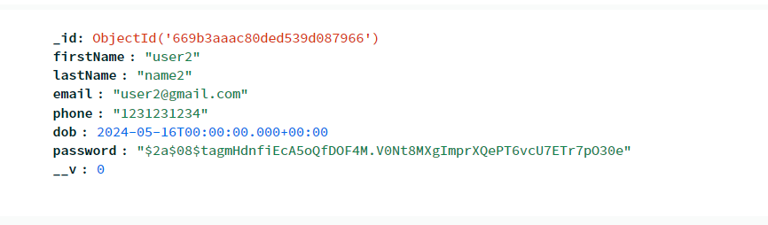

2. Collection: Complaints

- Schema:

{

_id: ObjectId,

Category:String,

othercategory: String,

state: String,

district: String,

pincode: String,

comment: String,

photo: String,

video: String

}

**Example:**

**_id**: ObjectId('668f88d3e799a94cf0a7e9d4')

**category**: "Road Issues"

**othercategory**: ""

**state**: "Tamil Nadu"

**district**: "Chennai"

**pincode**: "600001"

**comment**: "Road is heavily damaged with a lot of potholes"

**photo**: "uploads\1720682707422-roadblock.jpg"

**video**: "uploads\1720682707424-road block.mp4"

**__v**: 0

3. Collection: feedback

- Schema:

```

{

_id: ObjectId,

Name: String,

Email: String,

Rating: String,

Comments: String

}

```

**Example:**

**_id**: ObjectId('6691234db9c4d53c2fd49afa')

**name**: "Max"

**email**: "Max06@gmail.com"

**rating**: "4"

**comment**: "very good and user friendly"

**__v**: 0

4 Collection: Admin

-Schema:

{

_id : ObjectId

 email: String,

    phone: type: String ,

    password: type: String ,

}

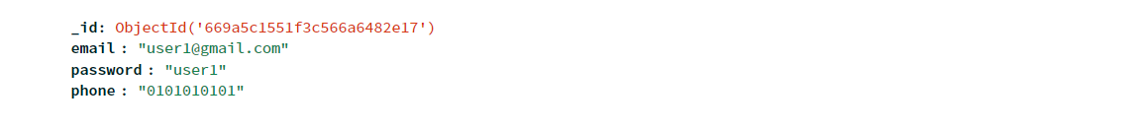

**Integration with Backend**

* Database connection:



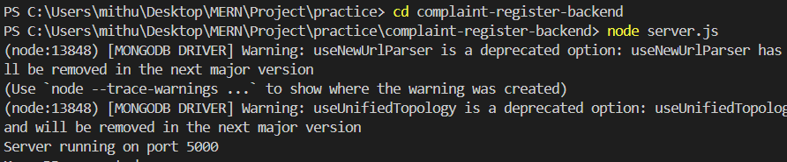

* The backend APIs interact with MongoDB using Mongoose ODM Key interactions include:
  + User Management: CRUD operations for user sign up and login.
  + Complaint Management: CRUD operations for complaint registration.
  + Feedback Management: CRUD operations for Feedback collection.
  + Admin Login Management: CRUD operations for Admin Login